Creating a Pull Request (PR) in GitHub
Purpose: Submit new or updated work for review before merging into the main branch. Ensures code quality, documentation, team visibility, and version control best practices.

- Navigate to the Correct Repository
  - Go to you’re the Decision Support GitHub page → Repositories.
  - Select the relevant repository.
  - Navigate to the correct folder and confirm location.
- Upload Your File
  - Click Add File → Upload Files.
  - Drag/drop or choose your file.
  - Confirm file appears in correct folder.
- Create a New Branch
New File
feature/. . .
Update File
fix/. . .
  - Select Create a new branch for this commit and start a pull request.
  - Use clear naming: feature/short-description or fix/short-description.
    - Example: feature/advisor-outreach-query.
- Propose the Change
  - Click Propose Changes to complete your PR details.
- Complete the Pull Request
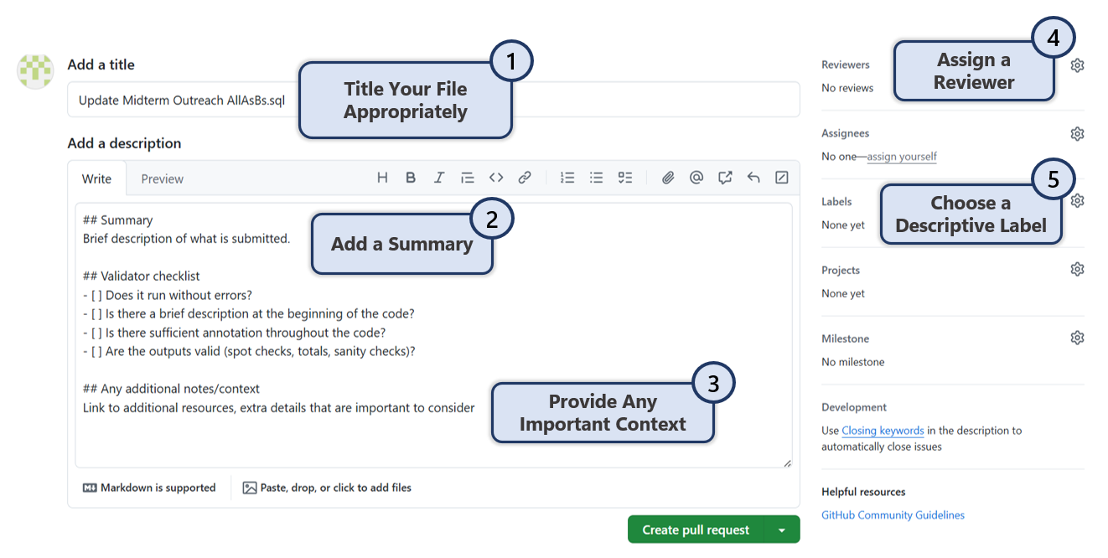
- Create the Pull Request Click Create Pull Request.
  - The reviewer will receive an email and can request changes, approve, or merge.

